County Councillor Update  Coker Division SCC  Cllr Mark Keating  October 2020 |  | 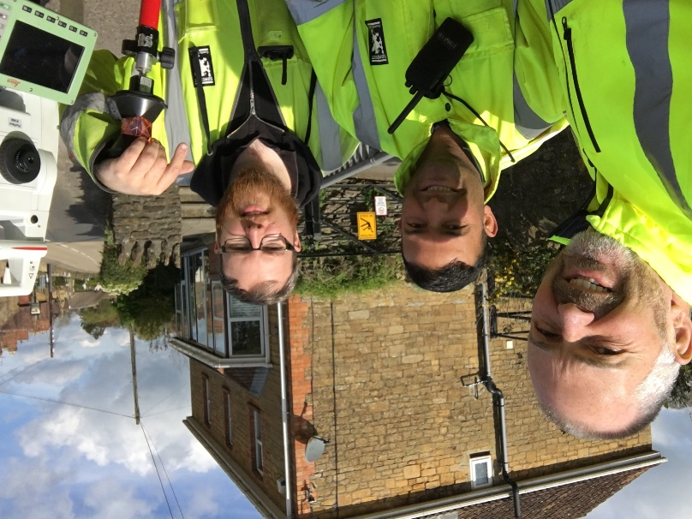
Representing you in - Barwick, Chiselborough, Closworth, East Chinnock, East Coker, Hardington Manderville, Hardington Marsh, Hardington Moor, Haselbury Plucknett, Middle Chinnock, Montacute, North Coker, North Perrott, Norton Sub Hamdon, ​Odcombe, Pendomer, Sutton Bingham, Stoford, West Chinnock, West Coker.
Useful Contacts Resources and Websites: Somerset Coronavirus Support Helpline: 0300 7906275
Cllr Mark Keating – Somerset County Council | E: MAKeating@Somerset.gov.uk | M: 07767 203968
South Somerset Area Highways Office | E: countyroads-southsom@somerset.gov.uk | T: 0300 123 2224
Report Pothole/Road Defect | E: roadsandtransportSD@somerset.gov.uk | T: 0300 123 2224
Report Dead Animal/Mud on Road | E: roadsandtransportSD@somerset.gov.uk | T: 0300 123 2224
Neil McWilliams – Highways Service Manager | E: countyroads-southsom@somerset.gov.uk | T: 0300 123 2224
Lee Norman/Derek Davies – Assist Highways Service Manager | E: countyroads-southsom@somerset.gov.uk | T: 0300 123 2224
Garry Warren/Rebecca Vaughan – Traffic Engineer. Traffic & Transport Development | E: countyroads-southsom@somerset.gov.uk | T: 0300 123 2224
Gully Emptying / Road Sweeper | E: chris.holley@southsomerset.gov.uk | T: 01935 462462
Nick Allen – SSDC Ranger Scheme | E: nick.allen@southsomerset.gov.uk | T: 01935 462462
Road Records & Highway Licensing | E: Roadrecords@Somerset.gov.uk | T: 0300 123 2224

Report Adult at Risk | adults@somerset.gov.uk |  |  | T: 0300 123 2224  T: Emergency: 999
Report Child at Risk | childrens@somerset.gov.uk |  |  | T: 0300 123 2224  T: Emergency: 999
Children’s Social Care Worker out of hours Emergency Duty Team |  |  |  | T: 0300 123 2327
Fostering and Adoption www.fosteradoptsomerset.org.uk | AandFRecruitmentEnquiryLine@somerset.gov.uk |  |  | T: 0800 587 9900
www.somersetwaste.gov.uk |  | ssdc@southsomerset.gov.uk | T: 01935 462462
https://www.travelsomerset.co.uk/ |  | Travel - Drive Bus Train Walk Cycle Weather
www.somerset.gov.uk |  | generalenquiries@somerset.gov.uk | T: 0300 123 2224
http://roadworks.org/ |  | Useful website for road works info
www.facebook.com/somersetcountycouncil |  | Somerset County Council Facebook page
https://roam.somerset.gov.uk/roam/map |  | Interactive Rights of Way Map / maintenance reporting

Corona Virus Update: In the last three weeks there has been a marked increase in the number of positive tests across the County but particularly in Sedgemoor and Mendip. As at 30th September, the number of confirmed Covid cases in Somerset was 1,585 and the number of Covid-attributed deaths 206. The rate per 100,000 currently stands at 10.4 for Somerset (Burnley by comparison is 314). The current number of total deaths across the County is currently 6% below the 5-year average and the latest R-value for Somerset is between 1.1 and 1.4.
It is vitally important to remember the Hands-Face-Space message.

Important invitation to all Parish Councillors

One Somerset - Single Unitary Authority for Somerset: Four virtual briefing meetings for Parish Councillors are being held on:

• Thursday 8th October 7pm
• Wednesday 14th October 7pm
• Thursday 15th October 1pm
• Thursday 15th October 7pm
Interested Councillors should email onesomerset@somerset.gov.uk to confirm their attendance, clearly stating which meeting they would like to attend. They will then be sent the link and joining instructions in advance.
Return to School: The number of children attending Somerset schools reached 56,410 on 10th September (92.4% attendance), before dropping slightly and then fluctuating between 88% – 94.3% - explained in part, by the required self-isolation of around 1,409 children from six schools after eleven positive COVID-19 tests in mid-September. Separately, Electively Home Educated pupil numbers have doubled – the estimate for September is 200 in comparison to highest total in previous years of 92.
2021 School Places: Whether a child is starting school for the first time, or transferring to their next school, applications need to be made through Somerset County Council’s website: www.somerset.gov.uk/admissions The deadline for applications for secondary school places is Saturday, 31 October 2020 and the deadline for primary school place submissions is Friday, 15 January 2021.

County Council Finances: Somerset County Council’s significantly improved finances have been recognised by independent auditors in their end of year report. The turnaround in just two years has seen the Council move from an “adverse” conclusion to “unqualified”– going from a very challenging position to the top ranking. The findings from auditors Grant Thornton say the Council has made “significant progress” over the past two years in improving its position. This means the Council is now in a strong position to face unexpected financial challenges. Throughout the coronavirus pandemic Somerset has been more resilient than many other councils regionally and nationally.
£1m Climate Emergency Fund: From 1st October, City, Town and Parish councils across Somerset are invited to bid for between £5,000 and £75,000 for innovative projects that can make a real difference in reducing carbon emissions and can contribute to making Somerset resilient to the effects of Climate Change. For information about the scheme, eligibility criteria and application process, visit www.somerset.gov.uk/climate-emergency.

Library Services: From Monday 5 October iPads will be available to job seekers looking for an extra bit of help in their quest for employment. The free iPad Loan Scheme from Somerset County Council is designed to help people looking for a new job or career but who may not have the IT skills or equipment they need. The tablets which are pre-loaded with links, information and support for anyone in Somerset currently looking for employment are available for up to six weeks free of charge from Bridgwater, Chard, Minehead, Shepton Mallet and Taunton libraries.
The Somerset Fund: Grassroots community groups based in Somerset can now apply for grants up to £2,500 from The Somerset Fund. Somerset Community Foundation (SCF) manages the Fund and is encouraging applications from community groups that run on less than £100,000 per year. The grants are ‘unrestricted’, which means they can be used to pay for ongoing running costs. Applications to the Fund through SCF’s website can be made until Friday 16 October 2020.

School Transport: Wearing face coverings on public transport services –used by pupils – is mandatory as part of the Government’s COVID-19 guidelines but whilst it’s not currently mandatory for pupils to wear coverings on dedicated transport all secondary age pupils who can, are now being urged to voluntarily wear coverings.

